

VII SEMINAR and WORKSHOP in OCEAN ENGINEERING
Rio Grande, November 23rd to 25th, 2016

ARTICLE TITLE

First author¹, Second author², Third author³

¹ First autor affiliation
First author address
e-mail: first author
² Federal University of Rio Grande - FURG
Graduate Program in Ocean Engineering
Avenida Itália, km 8, CP. 474, Rio Grande, RS, Brazil
*e-mail: semengo2016@gmail.com
³Third autor affiliation
Third author address
e-mail: Third author

ABSTRACT (Times New Roman, 10 pt, bold, upper case)

The purpose of these instructions is to serve as a guide for formatting articles to be published in the Proceedings of VII Seminar and Workshop in Ocean Engineering (VII SEMENGO). The abstract should describe the objectives, methodology and key findings of the article in less than 3000 characters, in a single paragraph. Equations and citations of published papers should not be included in the Abstract (Times New Roman, Italic, 10 pt).

1. NOMENCLATURe (Times New Roman, 10 pt, bold, upper case)

The nomenclature is optional, but, if it is inserted, must be entered as a separate section before the introduction. Greek, subscripts and superscripts symbols must be provided in separate subsections. The nomenclature should be formatted in two columns to optimize space.

2. INTRODUction (Times New Roman, 10 pt, bold, upper case)

The VII SEMENGO Proceedings will be published in digital format (PDF - Portable Document Format). Articles should be formatted strictly according to the instructions given here. This file can be used as a template for WORD users (.doc format).
The final article should not exceed 10 pages. This should be converted to PDF format and must not exceed the size of 3MB. The submission of the final article, in PDF format, must be made by the e-mail: semengo2016@gmail.com.

3. TEXT FORMAT (Times New Roman, 10 pt, bold, upper case)

Manuscripts should be written in Portuguese or English, on A4-size pages. The main text should be written using Times New Roman font with 10 pt. Single spacing should be used throughout the text. Pages should not be numbered. Pages should have a left side margin of 30 mm and all other margins (right, top and bottom) should be 20 mm.

3.1 Body text (Times New Roman, 10pt, bold, lower case)

The body text should be justified. The first line of each paragraph should have a 5 mm tab. Sufficient information must be provided directly in the text. Footnotes should be avoided. All symbols and notations must be defined within the text. Physical quantities must be expressed in the International System of Units (S.I.). Mathematical symbols and variables that appear in the text should be typed in italic.

3.2 Titles and Subtitles (Times New Roman, 10 pt, bold, lower case)

The titles and subtitles of the sections should be aligned to the left, typed in Times New Roman font, in bold, font size 10 pt. Subsections should be numbered using Arabic numerals separated by points. The number of sub-levels should not exceed 3 (three). Moreover, these subsections should be typed in lowercase. A single space should be used before and after the title and subtitle of each section.

3.3 Mathematical equations (Times New Roman, 10 pt, bold, lower case)

Mathematical equations should be distant 5 mm from the left margin. Equations should be typed using Times New Roman italic font with size 10 pt. Arabic numbers should be used in the equations. Equations should be referred to as "Eq. (1)" in midsentence and as "Equation (1)" at the beginning of the sentence. Vectors and tensors must be indicated in bold italics, as can be seen in Eq. (1), or using indicial notation, as shown in Eq. (2). Symbols and variables used in the equations must be formatted in italics and should be defined immediately after their first appearance in the text.

(1)

(2)

3.4 Figures and Tables (Times New Roman, 10 pt, bold, lower case)

Figures and tables should be placed in the text as close as possible to the point where they were first mentioned (never before cited in the text) and should be numbered consecutively in Arabic numerals. Figures should be referenced in the text as "Fig. 1" in midsentence and "Figure 1" at the beginning of the sentence. The figures, as well as their titles should be centered horizontally. The titles must be located after the pictures and not having more than three (3) lines. A blank spacing should be included before and after each figure.

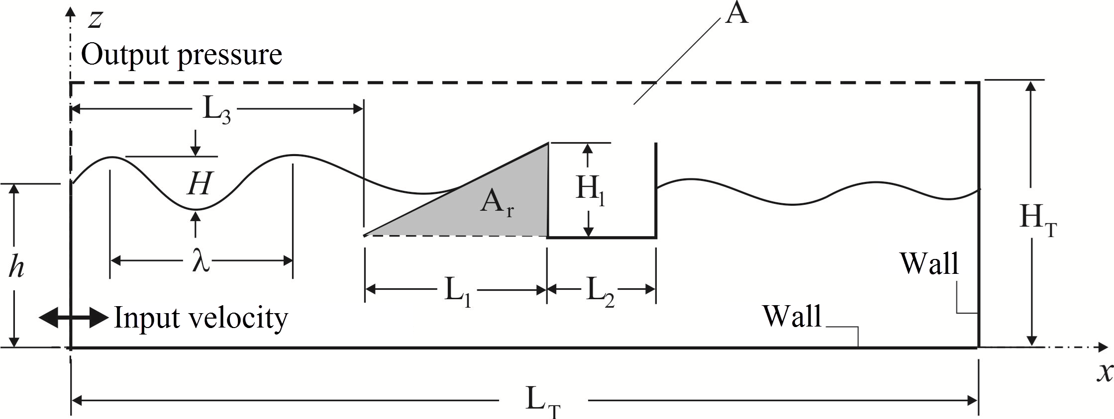

Figure 1. Computational domain of the overtopping device for wave energy conversion.
If the figure was a graphic, the subtitle for the data symbols, as well as the labels for each curve must be included in the figure. The text subtitle within the picture must have font size of 10 pt at least to enable (facilitate) reading. All units must be expressed in the International System of Units (S.I.).
Color figures and high-resolution photographs can be included in the article. To reduce the size of the file and preserve the graphic resolution, bitmap figures should be inserted in the manuscript in a compressed format (JPGE) or (TIFF).
Tables should be referred to as "Tab. 1" in midsentence or "Table 1" at the beginning of the sentence. The tables and their titles should be centralized. The titles of tables should not exceed three (3) lines and should be placed before the table in the text. The font style and size should be similar to those used in the text. Dimensional units should be expressed in the International System of Units (S.I.). Explanations, if any, should be given in the text after the insertion of the table. Furthermore, it should be left a blank space before and after each table. The style of table borders is left free, an example is shown in Tab. 1.

Table 1. Physical and computational parameters for the channel flow simulation.
Parameter | Channel flow
Reynolds number (Re_{c} = u_{c}H/2ν) | 3330
Reynolds number (Re_{m} = u_{m}H/ν) | 5705
Reynolds number (Re_{τ} = u_{τ}H/2ν) | 180
Prandtl number (Pr) | 0.71
Domain (x*,y*,z*) | 3.2 × 1.0 × 1.6
Mesh (x*, y*, z*) | 100 × 60 × 60
Time step (∆t) | 2.5 × 10⁻⁵ s

3.5 References (Times New Roman, 10 pt, bold, lower case)

References should be cited in the text using the last name of the author(s) and year of publication, according to the following examples: "In the work of (Vajjha and Das, 2009) ..." or " Vajjha and Das (2009) ... ". In the case of 3 (three) or more authors, the form "(Panaras et al., 2010)" should be used. Two or more references that have the same author and year of publication should be distinguished by inserting "a", "b", etc., after the year of publication. For example: "In the articles (Simonson and Besant, 1999a) and (Simonson and Besant, 1999b) ...".
Acceptable references include journal articles (Özisik and Murray, 1974), dissertations and theses (Charoensupaya, 1986; Aparecido, 1988), conference and congress articles (Tuckerman and Pease, 2011), books (Mikhailov and Özisik, 1984) and articles submitted (if the journal is identified). References should be listed at the end of the article according to the instructions in Section 5.

4. ACKNOWLEDGEMENTS (Times New Roman, 10 pt, bold, uppercase)

This optional section should be inserted before the reference list.

5. REFERENCES (Times New Roman, 10 pt, bold, uppercase)

The list of references should be introduced as a new section, located at the end of the article. The first line of each reference should be aligned to the left. All other lines should be tabulated to 5 mm from the left side margin. All references included in the reference list must have been previously mentioned in the text. References should be listed in alphabetical order, according to the last name of the first author. Consider the following examples:

Aparecido, J.B., 1988. Transformada Integral Generalizada no Escoamento Laminar e Transferência de Calor em Dutos Retilíneos de Geometria Arbitrária. Ph.D. thesis, Instituto Tecnológico de Aeronáutica, São José dos Campos, SP, Brasil.
Charoensupaya, D., 1986. Experimental and Analytical Investigations of Composite Desiccant Structures and Low Humidity Adsorption. Ph.D. thesis, Illinois Institute of Technology, Chicago, IL, USA.
Mikhailov, M.D. and Özisik, M.N., 1984. Unified Analysis and Solutions of Heat and Mass Diffusion. John Wiley & Sons, New York.
Özisik, M.N. and Murray, R.L., 1974. “On the solution of linear diffusion problems with variable boundary condition parameters”. Journal of Heat Transfer (ASME), Vol. 96, pp. 48–51.
Panaras, G., Mathioulakis, E., Belessiotis, V. and Kyriakis, N., 2010. “Experimental validation of a simplified approach for a desiccant wheel model”. Energy and Buildings, Vol. 42, No. 10, pp. 1719–1725.
Simonson, C.J. and Besant, R.W., 1999a. “Energy wheel effectiveness – part I: Development of dimensionless groups”. International Journal of Heat and Mass Transfer, Vol. 42, pp. 2161–2170.
Simonson, C.J. and Besant, R.W., 1999b. “Energy wheel effectiveness – part II: Correlations”. International Journal of Heat and Mass Transfer, Vol. 42, pp. 2171–2185.
Tuckerman, D.B. and Pease, R.F.W., 2011. “Microchannel heat transfer: early history, commercial applications, and emerging opportunities”. In Proceedings of the ASME 2011 9th International Conference on Nanochannels, Microchannels, and Minichannels. Edmonton, Alberta, Canada. Paper no. 58308.
Vajjha, R.S. and Das, D.K., 2009. “Experimental determination of thermal conductivity of three nanofluids and develop- ment of new correlations”. International Journal of Heat and Mass Transfer, Vol. 52, No. 21-22, pp. 4675–4682.

6. RESPONSIBILITY NOTICE (Times New Roman, 10 pt, bold, uppercase)

The content of the text is the entire responsibility of the author(s), and does not necessarily reflect the opinion of the Editor, or the members of the Editorial Board.

